 |  | 
MANSOURA UNIVERSITY
FACULTY OF ENGINEERING
ARTIFICIAL INTELLIGENCE ENGINEERING Program

RLGUI
Project members | ID number
Mohammed Salah El-deen Aboelkher | 808860588
Ahmed Osama Ahmed Awad Kosba
Ahmed Khaled El-Sayed Mohammed Orapy | 812082508
Kirellos Yousef Samy Yousef Mansour | 808971160
Omar Ali El-Sherbiney Awad | 808979350

Supervisor
Prof. Dr. Mahmoud Safaan El-Sayed Mousa

Academic Year: 2025 – 2026
June 2025

ABSTRACT
Reinforcement Learning (RL) presents a powerful paradigm for sequential decision-making, where agents learn through trial-and-error interaction with an environment to maximize cumulative rewards. Despite its potential, RL's adoption is hindered by complexities in defining reward functions, managing the exploration-exploitation dilemma, and higher computational demands compared to supervised and unsupervised learning. To address these challenges, RLGUI was developed. RLGUI is a highly configurable suite offering ready-to-use RL environments and algorithms within an integrated graphical user interface (GUI). This platform provides real-time inspection and observability into the agent's training process, significantly lowering the barrier to entry and accelerating the training and observation of RL agents for both newcomers and experienced researchers

ACKNOWLEDGEMENTS
We would like to express our deepest gratitude to all those who contributed to the successful completion of this graduation project.
Our sincere appreciation goes to our academic supervisors, Dr. Mahmoud Safaan and Eng. Mostafa Ahmed. Their invaluable guidance, insightful feedback, and unwavering support throughout the entire project were instrumental in shaping our work. Their expertise and encouragement truly made a significant difference for our team.
We are immensely grateful for the strong teamwork and collaborative spirit among our own team members. Our collective dedication, hard work, and mutual support were essential to achieving our goals. This project would not have been possible without the contributions of each and every one of us.
Furthermore, we extend our thanks to the students who viewed our project and provided invaluable feedback. Their fresh perspectives and constructive criticism greatly helped in refining our work and addressing key areas for improvement.
Finally, we would also like to thank the various online communities that helped us build the vision of RLGUI.
Thank you

TABLE OF CONTENTS
ABSTRACT ii
ACKNOWLEDGEMENTS iii
TABLE OF CONTENTS iv
LIST OF FIGURES v
LIST OF ABBREVIATIONS vi
1 Overview 2
2 Walkthrough 9
3 Software 19
4 Architecture 26
5 Code Structure 33
6 Future Roadmap and Discussion 39
References 42
APPENDICES 44
Appendix A. 44

LIST OF FIGURES
Figure ‎1-1 RLGUI Logo. 2
Figure ‎1-4 RLGUI start screen. 5
Figure 2-1-1 RLGUI Environment Dialog. 9
Figure 2-1-2 RLGUI Environment Dialog Cliff Walking selected. 10
Figure 2-1-3 RLGUI Environment Space type indicator 10
Figure 2-1-4 RLGUI Main Window Environment Selected. 11
Figure 2-1-4 RLGUI Main Window Environment Selected. 12
Figure 2-2-2 RLGUI Main Window Algorithm Options. 13
Figure 2-2-3 RLGUI Training Process started. 13
Figure 2-3-1 RLGUI Training Processes Tab. 14
Figure 2-3-2 RLGUI Training Process Inspection Dialog. 15
Figure 2-3-3 Tensorboard logged reward function. 15
Figure 2-3-4 Tensorboard logged Q-values. 16
Figure 2-3-5 Tensorboard logged value function and policy. 16
Figure 3-2-1 Ruff Logo. 19
Figure 3-2-2 Pre-commit Logo. 20
Figure 3-3-1 Typer Logo. 21
Figure 3-4-1 Gymnasium Logo. 21
Figure 3-5-1 Pytorch Logo. 22
Figure 3-6-1 Pyinstaller Logo. 23
Figure 3-7-1 PySide6 Logo. 23

LIST OF ABBREVIATIONS
RL  GUI  ML | Reinforcment Learning  Graphical User Interface  Machine Learning

CHAPTER 1
OVERVIEW

Overview


Figure ‎1-1 RLGUI Logo.

The Landscape of Machine Learning Paradigms
The field of machine learning is broadly categorized into three primary paradigms: supervised learning, unsupervised learning, and reinforcement learning (RL). Each paradigm offers a distinct approach to learning and problem-solving, catering to different types of data and objectives.

Supervised Learning
Supervised learning, the most prevalent of the three, operates on labeled datasets. In this approach, algorithms learn a direct mapping between input features and predefined output labels. The goal is to generalize from this labeled data to accurately predict outcomes for unseen inputs. Common applications include image classification, spam detection, and predictive analytics, where abundant labeled data is typically available to train robust models.

Unsupervised Learning
In contrast to supervised learning, unsupervised learning deals with unlabeled data. Its primary objective is to discern inherent structures, patterns, or relationships within the data without any explicit guidance or predefined outputs. Techniques like clustering, dimensionality reduction, and anomaly detection fall under this category. Unsupervised learning is particularly useful for exploratory data analysis, data compression, and identifying hidden insights in large datasets where labeling is impractical or impossible.

Reinforcement Learning: A Distinct Approach
Reinforcement Learning (RL) distinguishes itself fundamentally from both supervised and unsupervised learning through its iterative interaction-based learning mechanism. Instead of learning from static datasets (labeled or unlabeled), RL agents learn by continuously interacting with an environment. The learning process is driven by scalar feedback in the form of "rewards" or "penalties," which the agent receives after performing actions. The overarching objective of an RL agent is to maximize the cumulative reward over a sequence of actions, rather than to predict a specific outcome or categorize data. This trial-and-error, goal-driven approach allows RL agents to develop optimal policies for sequential decision-making problems, making it particularly well-suited for tasks such as robotics, game playing, and resource management.

The Promise and Challenges of Reinforcement Learning
RL holds significant potential for solving complex sequential decision-making problems that are difficult to address with traditional machine learning methods. Its ability to learn optimal behaviors through interaction makes it a powerful tool for autonomous systems and intelligent agents. However, despite its promise, RL's adoption rate remains comparatively lower within the broader machine learning landscape. This lower adoption can be attributed to several inherent complexities and implementation challenges.

Defining Effective Reward Functions
One of the primary challenges in RL is the intricate task of defining effective reward functions. A well-designed reward function is crucial as it shapes the agent's behavior and guides it towards the desired objective. Poorly designed reward functions can lead to suboptimal policies, undesirable behaviors, or slow convergence. Crafting a reward function that accurately reflects the problem's goals and encourages the desired learning trajectory often requires significant domain expertise and iterative refinement.

The Exploration-Exploitation Dilemma
Another significant hurdle in RL is managing the exploration-exploitation dilemma. During training, an RL agent must balance between "exploring" new actions and states to discover potentially better strategies, and "exploiting" its current knowledge to maximize immediate rewards. Over-exploring can lead to inefficient learning, while over-exploiting can result in the agent getting stuck in suboptimal local optima. Finding the right balance is critical for ensuring comprehensive environmental interaction and achieving optimal performance.

Computational Demands
Reinforcement learning algorithms typically exhibit higher computational demands than their data-centric supervised and unsupervised counterparts. The iterative nature of interaction with the environment, coupled with the need for extensive data collection through trial-and-error, often requires significant processing power and time. This can be a barrier for researchers and developers with limited computational resources, further contributing to the challenges of widespread RL adoption.

The Need for a User-Friendly Reinforcement Learning Platform
The challenges outlined above often present considerable implementation complexities for individuals and organizations venturing into reinforcement learning. The absence of readily available, integrated tools comparable to those found in supervised learning (e.g., scikit-learn for traditional machine learning) exacerbates these difficulties. Researchers and developers often find themselves juggling a multitude of disparate tools, libraries, and environments, leading to a steep learning curve and inefficient development workflows. This fragmentation motivated the development of a comprehensive and user-friendly solution.

RLGUI: A Solution for Accessible Reinforcement Learning
The inception of RLGUI was driven by a practical need for a more accessible and efficient way to engage with reinforcement learning. What began as an ambition to control an ant robot quickly highlighted the significant difficulties in learning and applying various RL algorithms across diverse environments. This hands-on experience underscored the necessity for a more integrated and intuitive platform.

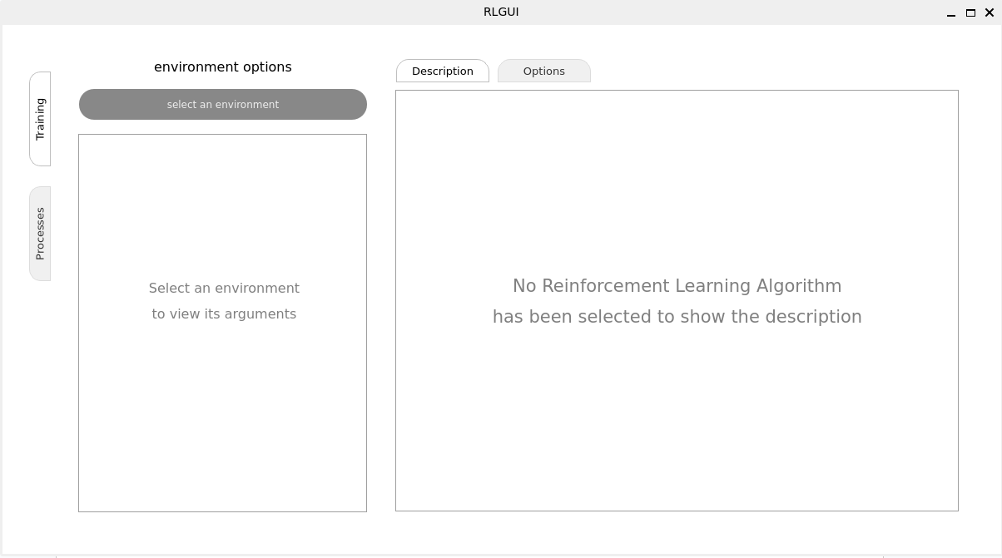
Figure ‎1-4 RLGUI start screen.

The Genesis of RLGUI: From Concept to GUI
The initial realization of the fragmented RL ecosystem led to the idea of creating a guide that would map out which algorithms perform optimally in specific environments. This concept evolved into the development of a user-friendly API designed to streamline the process of applying RL algorithms. However, as the API development progressed, a pivotal decision was made to elevate the solution further by building a full-fledged Graphical User Interface (GUI).

Addressing the Fragmentation of RL Tools
The developers recognized that a GUI would serve as a crucial unifying layer, packaging everything neatly for both newcomers and seasoned researchers. This integrated approach directly addresses the existing fragmentation of RL tools and libraries, eliminating the need to piece together disparate components. The GUI provides a centralized hub where users can seamlessly access environments, algorithms, and training parameters, significantly reducing the initial setup and configuration overhead.

Lowering the Barrier to Entry
A primary objective of RLGUI is to drastically lower the barrier to entry for individuals interested in reinforcement learning. The intuitive visual interface replaces complex command-line interactions and extensive coding, making RL concepts more approachable for those without deep programming expertise. By simplifying the interaction with RL algorithms and environments, RLGUI empowers a broader audience to experiment with and understand reinforcement learning principles.

Accelerating Training and Observation
Beyond accessibility, RLGUI is designed to drastically cut down the time it takes for users to train and observe their first reinforcement learning agents. The GUI facilitates rapid experimentation by allowing users to easily configure and launch training runs. More importantly, it provides real-time inspection and observability into the agent's training process. This real-time feedback allows users to monitor key metrics, visualize agent behavior, and identify issues or successes as they happen, leading to faster iteration and more efficient learning.

RLGUI: A Comprehensive and Configurable Suite
RLGUI is defined as a highly configurable suite of ready-to-use environments and algorithms for reinforcement learning. This definition highlights key aspects of its design and functionality.

Ready-to-Use Environments and Algorithms
The "ready-to-use" aspect of RLGUI signifies that users do not need to spend time setting up and configuring various RL environments and algorithms from scratch. The suite comes pre-equipped with a selection of popular and well-tested environments (e.g., classic control tasks, locomotion environments) and a range of established RL algorithms (e.g., Q-learning, Deep Q-Networks, Policy Gradients). This immediate access to pre-built components enables users to dive directly into experimentation and learning without the overhead of initial setup.

High Configurability
While offering ready-to-use components, RLGUI also emphasizes high configurability. This means that users have extensive control over various parameters of both the environments and the algorithms. Users can fine-tune hyperparameters, modify reward structures, adjust network architectures, and customize other critical settings to suit their specific research questions or application needs. This flexibility allows for both quick prototyping and in-depth experimentation, catering to a wide range of user requirements.

Real-time Inspection and Observability
A cornerstone feature of RLGUI is its ability to provide real-time inspection and observability into the agent's training process. Traditional RL training often involves waiting for episodes to complete before analyzing logs or plotting results. RLGUI's GUI-driven approach allows for dynamic visualization of training progress, including reward curves, loss functions, and even the agent's behavior within the environment as it learns. This immediate feedback loop is invaluable for understanding the agent's learning dynamics, debugging issues, and gaining insights into the effectiveness of different algorithms and configurations. This continuous feedback significantly enhances the user's ability to interpret and respond to the training process.

CHAPTER 2
Walkthrough

Walkthrough
Within this chapter, a complete walkthrough of the RLGUI software is presented, covering the entire process from environment selection to agent training and observation.

RLGUI Environment Selection
To initiate a Reinforcement Learning (RL) training process, several components are essential. The most crucial among these is the environment, which serves as the interactive space for the agent to learn and accumulate experience. Upon launching the application, clicking the "select an environment" button opens the environment selection dialog box (Figure 2-1-1). Selecting an environment then displays its pertinent information within the main window, as illustrated in Figure 2-1-2.

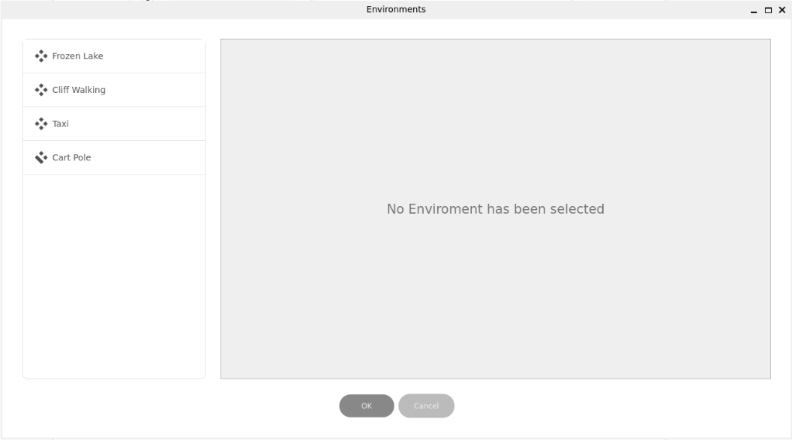
Figure 2-1-1 RLGUI Environment Dialog.

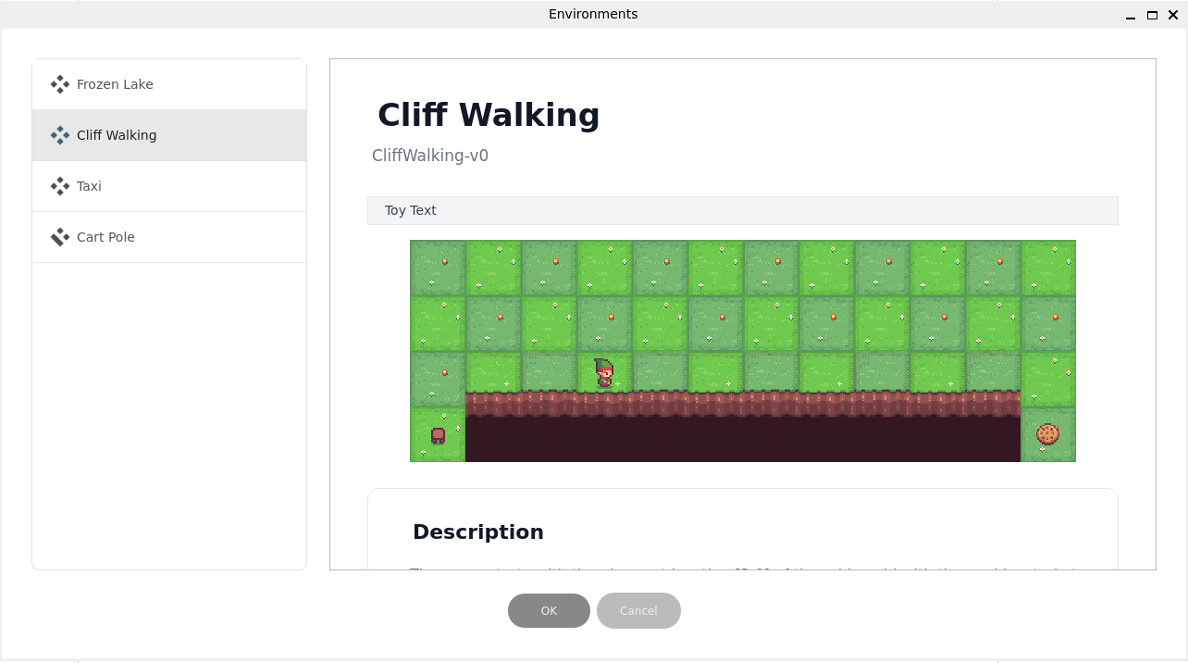
Figure 2-1-2 RLGUI Environment Dialog Cliff Walking selected.

Each environment in RLGUI features an icon next to its name, providing an at-a-glance indication of its action and observation space types, as shown in Figure 2.1.3. When you select an environment, the following information is displayed:
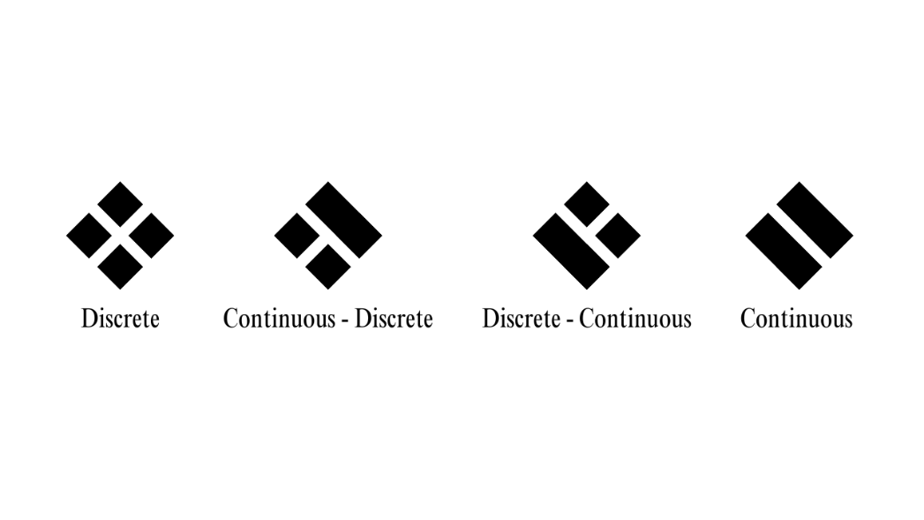
Figure 2-1-3 RLGUI Environment Space type indicator.

- Display Name
- Gymnasium ID
- Type
- GIF
- Description
- Action Space
- Observation Space
- Reward
- Episode Information
After clicking on “OK” The main Interface gets updated to display environment options on the left-hand side as shown in Figure 2-1-4

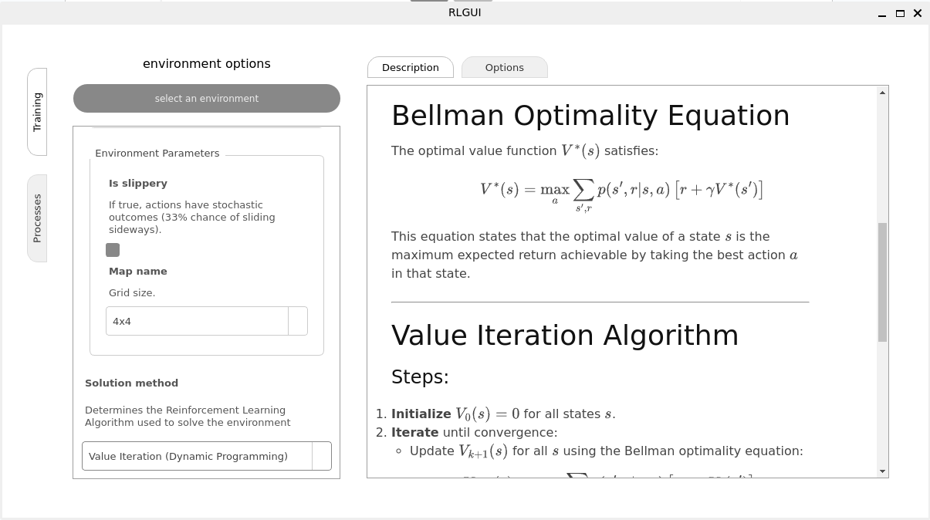
Figure 2-1-4 RLGUI Main Window Environment Selected.

RLGUI Algorithms Selection
Once an environment is selected, users can then specify a solution method located at the end of the environment configuration. This selection instantly updates the Algorithm Description tab, providing a detailed view of the algorithm's mathematical formulation and pseudocode, as shown in Figures 2-2-1 and 2-1-4.

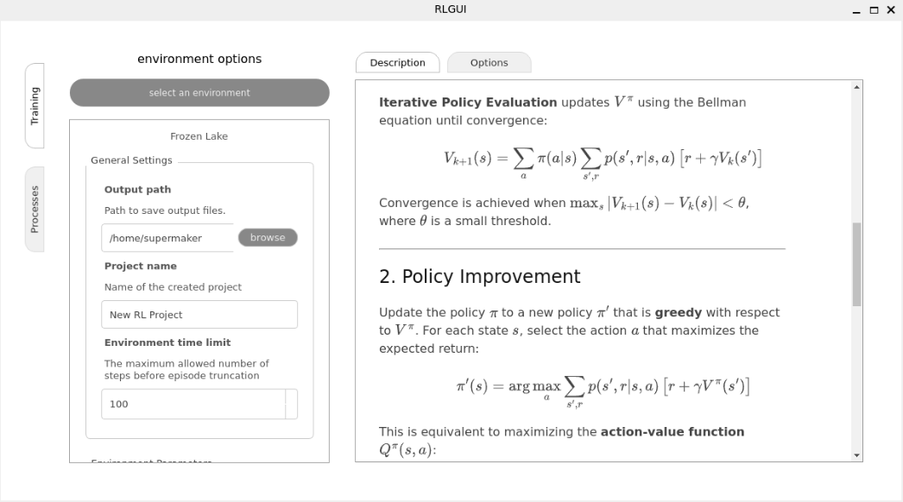
Figure 2-2-1 RLGUI Main Window Policy Iteration Algorithm.

To customize the training process, users can access diverse configurations within the Algorithm Options Tab, illustrated in Figure 2.2.2.

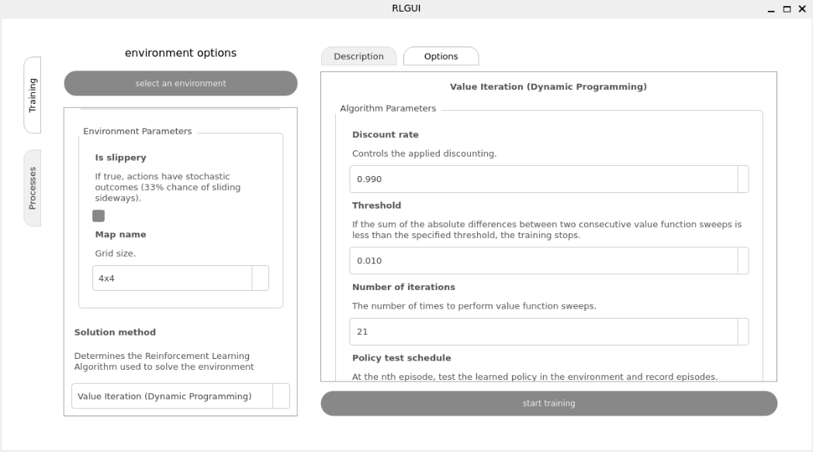
Figure 2-2-2 RLGUI Main Window Algorithm Options.

Subsequent to configuring the algorithm, the training process can be commenced by clicking the Start Training button. A notification, presented as a concise message box, will then confirm the initiation of training (Figure 2.2.3).

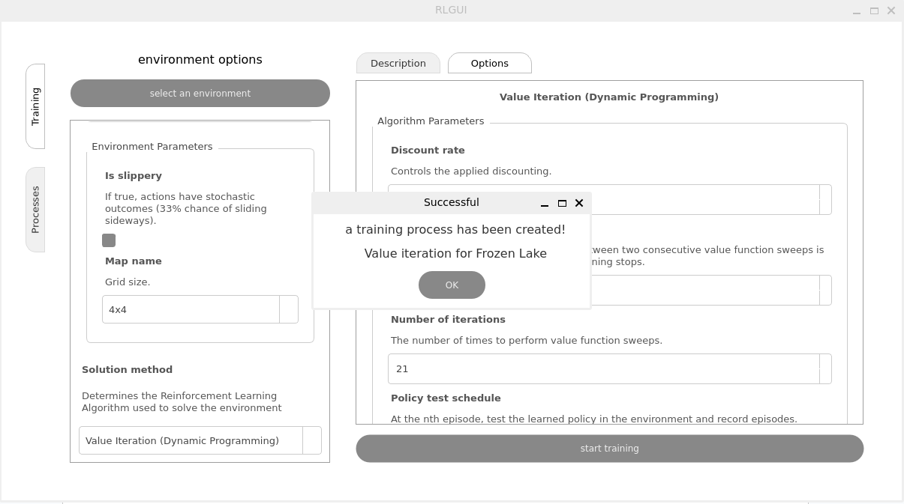
Figure 2-2-3 RLGUI Training Process started

RLGUI Training Observability
The Processes tab provides real-time monitoring of all active training processes, including their completion percentages Figure 2-3-1. To delve deeper, users can select a process and click "Inspect," which activates an inspection dialog. This dialog includes a slider that offers immediate, real-time visualization of episodes as the agent completes each one as illustrated in Figure 2-3-2

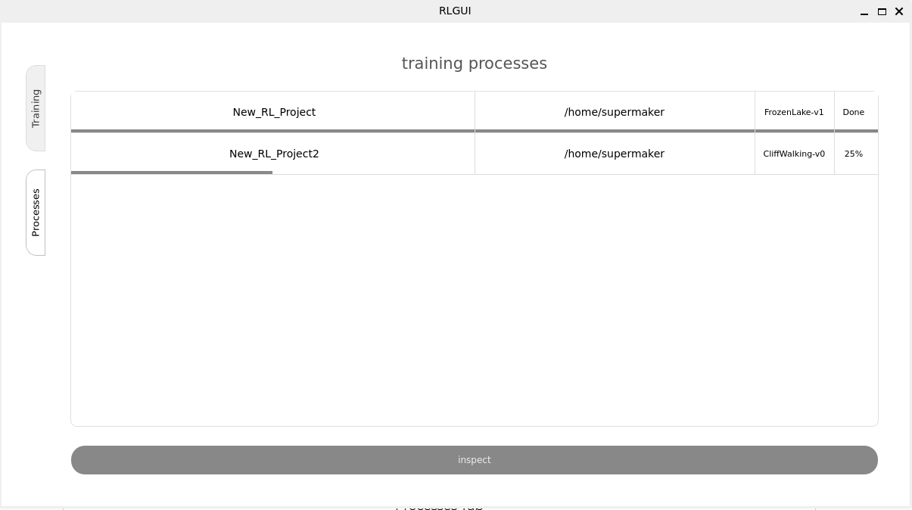
Figure 2-3-1 RLGUI Training Processes Tab

Additionally, it should be recognized that the training process systematically records significant data points pertaining to its execution. This logged information, encompassing state-values, action-values, and policy parameters, is stored in a TensorBoard-compatible format, thereby facilitating straightforward real-time visualization via the TensorBoard utility as shown in Figures 2-3-3, 2-3-4, and 2-3-5, more information about these metrics can be found in Appendix A

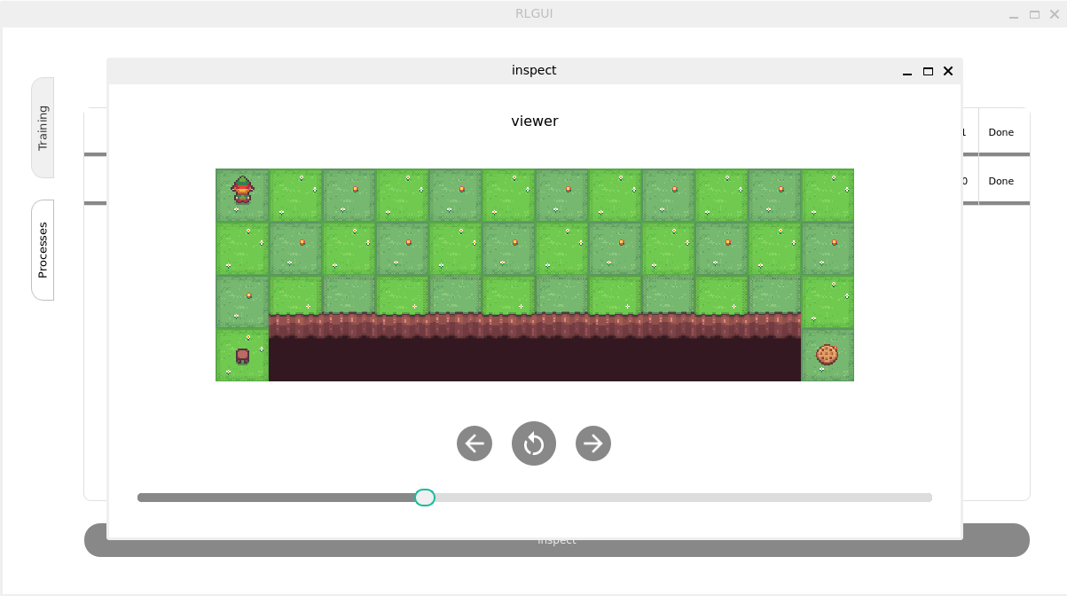
Figure 2-3-2 RLGUI Training Process Inspection Dialog

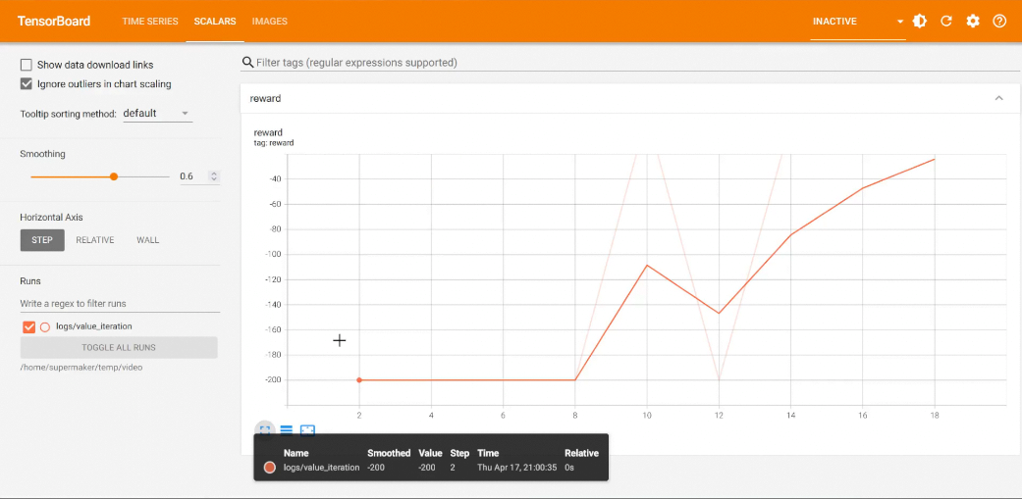
Figure 2-3-3 Tensorboard logged reward function

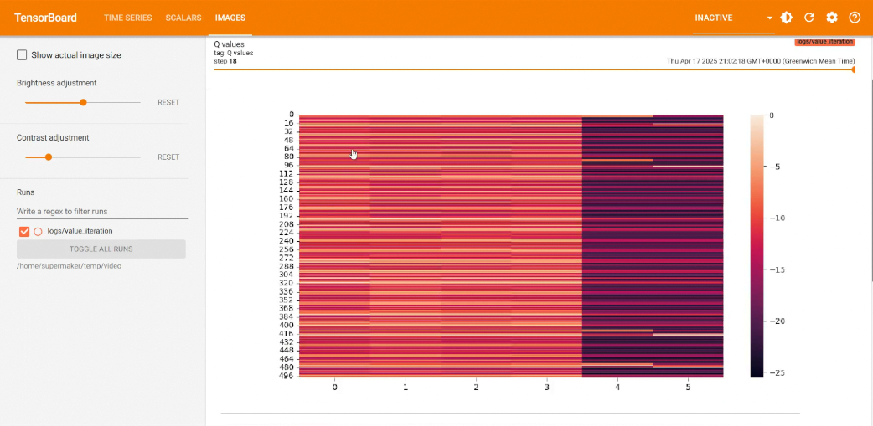
Figure 2-3-4 Tensorboard logged Q-values

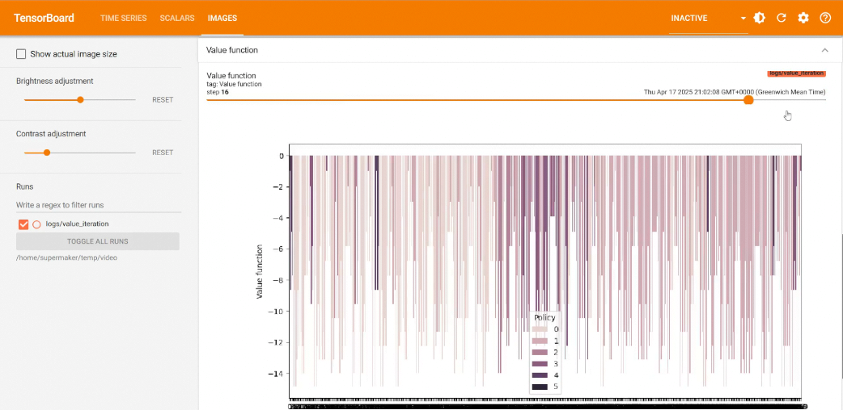
Figure 2-3-5 Tensorboard logged value function and policy

CHAPTER 3
Software

Software
The RLGUI application leverages the extensive capabilities of the Python ecosystem, utilizing a selection of robust frameworks and libraries to ensure efficiency, maintainability, and a user-friendly experience.

Core Development Language
The entire application is built upon Python, a high-level, interpreted programming language widely favored for its readability, extensive libraries, and strong community support. Python's versatility makes it an ideal choice for developing complex applications, including those involving machine learning and graphical user interfaces.

Code Quality and Style Enforcement
To maintain high code quality, consistency, and readability across the project, specific tools for linting and formatting were integrated into the development workflow.

Ruff
Ruff is utilized for code linting and formatting. As an extremely fast Python linter and formatter, Ruff helps in enforcing coding standards, identifying potential errors, and automatically formatting code to adhere to a consistent style. This significantly contributes to code maintainability and team collaboration.


Figure 3-2-1 Ruff Logo

Pre-Commit
Pre-Commit serves as a framework for managing and maintaining multi-language pre-commit hooks. Its integration ensures that code quality checks, including those performed by Ruff, are automatically run before each commit. This proactive approach prevents common issues from entering the codebase, ensuring that all submitted code adheres to defined style and quality guidelines.


Figure 3-2-2 Pre-commit Logo

Command Line Interface (CLI) Development
For specific functionalities that might require command-line interaction or utility scripting, a dedicated CLI development framework was employed.

Typer
Typer is used for building robust command-line interface applications. Based on Python type hints, Typer makes CLI development intuitive, fast, and easy to debug. It automatically generates CLI arguments, options, and commands, reducing boilerplate code and enhancing the developer experience.


Figure 3-3-1 Typer Logo

Reinforcement Learning Environment Integration
To facilitate interaction with various reinforcement learning environments, a standardized library was adopted.

Gymnasium
Gymnasium (formerly OpenAI Gym) is a widely recognized toolkit for developing and comparing reinforcement learning algorithms. It provides a standardized API for defining environments, allowing RL agents to interact and learn from a diverse range of tasks. Its inclusion in RLGUI ensures compatibility with a vast array of existing and future RL environments, providing a rich testing ground for algorithms.


Figure 3-4-1 Gymnasium Logo

Machine Learning Backend
For the implementation and execution of reinforcement learning algorithms, a powerful deep learning framework was chosen.

PyTorch
PyTorch is an open-source machine learning framework known for its flexibility, ease of use, and strong GPU acceleration. Its dynamic computation graph makes it particularly well-suited for research and rapid prototyping in deep learning, including complex reinforcement learning algorithms. PyTorch provides the foundational computational power for the RL algorithms within RLGUI.


Figure 3-5-1 Pytorch Logo

Application Packaging and Distribution
To create standalone, distributable versions of the RLGUI application, a specialized packaging tool was employed.

PyInstaller
PyInstaller is a program that bundles a Python application and all its dependencies into a single package. This allows RLGUI to be distributed as a standalone executable, enabling users to run the application on various operating systems without needing to install Python or manage dependencies separately.


Figure 3-6-1 Pyinstaller Logo

Graphical User Interface (GUI) Development
The core of RLGUI's user-friendly nature stems from its graphical interface, built using a robust GUI toolkit.

PySide6
PySide6 is the official Python binding for the Qt cross-platform application framework. It provides a comprehensive set of tools and widgets for creating rich, interactive graphical user interfaces. PySide6 was selected for RLGUI's GUI development due to its stability, extensive features, and ability to create native-looking applications across different operating systems, contributing significantly to the intuitive user experience.


Figure 3-7-1 PySide6 Logo

CHAPTER 4
Architecture

Architecture
To understand the architecture of the RLGUI application, it's essential to first establish a foundational understanding of how computer programs execute and manage their computational resources. This involves differentiating between processes and threads, and appreciating their roles in parallel and concurrent computing.

Understanding Program Execution: Processes and Threads
In modern operating systems, the execution of a program involves concepts of processes and threads, which are fundamental units of work and resource management.

Processes
A process can be thought of as an independent instance of a running program. When you launch an application, the operating system creates a new process for it. Each process has its own isolated memory space, its own set of resources (such as open files, network connections), and its own execution context. Processes are inherently isolated from one another, meaning that a crash in one process generally does not directly affect other processes. This isolation provides robustness and security. Communication between different processes typically requires specific inter-process communication (IPC) mechanisms, such as pipes, queues, or shared memory.

Threads
Within a single process, one or more threads can exist. A thread is often referred to as a "lightweight process" because it shares the same memory space and resources as its parent process. While processes are independent, threads within the same process can directly access the same data. This shared memory space makes communication between threads much faster and simpler than inter-process communication. However, it also introduces challenges related to data consistency and race conditions, requiring careful synchronization mechanisms (e.g., locks, mutexes) to prevent conflicts when multiple threads access and modify shared data concurrently.

How Programs Get Executed
When a program is executed, the operating system's scheduler allocates CPU time to its processes and their threads. A single-threaded program executes instructions sequentially. Multi-threaded programs, on the other hand, can perform multiple tasks concurrently within the same process by switching between threads rapidly (context switching) or, on multi-core processors, by truly executing threads in parallel on different cores. Similarly, multi-process applications can achieve parallelism by having different processes run simultaneously on different cores.

RLGUI's Out-of-Process Multi-Process Architecture
The RLGUI application is designed with an Out-of-Process Multi-Process Architecture. This design paradigm is a strategic choice to optimize performance, maintain responsiveness, and effectively manage resource-intensive operations, particularly given the characteristics of the Python programming language.

Main Process and GUI Responsiveness
The core of the RLGUI application is its Main process, which is dedicated to maintaining the Graphical User Interface (GUI). This main process runs a single, active thread primarily responsible for displaying the GUI and handling user interactions. This dedicated thread ensures that the GUI remains responsive and fluid, even when computationally intensive operations are running in the background. To handle I/O-bound tasks—operations that involve waiting for external resources, such as reading from a disk or network communication—additional threads can be spawned within this main process. These threads are efficient for I/O operations because they can yield control while waiting, allowing the main GUI thread to remain unblocked.

Background Processes for Heavy Lifting: RLCLI
The most distinctive aspect of this architecture lies in how it handles the "heavy lifting" of model training and extensive logging. Instead of performing these resource-intensive tasks within the main GUI process, the application spawns Background processes. These background processes are not simply new threads within the main application; rather, they are distinct processes created by launching a separate command-line application named RLCLI.
RLCLI (Reinforcement Learning Command-Line Interface) is a standalone application that encapsulates the entirety of the actual RL training logic and logging functionality. By exposing these capabilities via a command-line interface, RLCLI offers significant advantages:
- Encapsulation: The training logic is isolated from the GUI logic, promoting modularity and making RLCLI reusable as a standalone tool.
- Ease of Use: A CLI application is inherently designed for scriptability and automation, which is beneficial for managing training runs programmatically.
- Resource Isolation: Each spawned RLCLI process operates in its own memory space, preventing memory leaks or crashes in a training run from affecting the main GUI application.
When a user initiates a training process through the RLGUI, the GUI effectively sends a command to the operating system to launch an instance of RLCLI as a new, independent background process. This background process then handles the entire training cycle, including all the computational demands and logging, without burdening the main GUI thread.

Architectural Justification: The Python GIL and Overall Benefits
The choice of an Out-of-Process Multi-Process Architecture is particularly strategic and beneficial for Python-based applications like RLGUI, primarily due to the presence of the Global Interpreter Lock (GIL).

The Python Global Interpreter Lock (GIL)
The Python Global Interpreter Lock (GIL) is a mutex that protects access to Python objects, preventing multiple native threads from executing Python bytecodes at once. In simpler terms, even on multi-core processors, a standard CPython interpreter (the most common Python implementation) can only execute one thread at a time. This means that while Python threads are excellent for I/O-bound tasks (where the thread spends most of its time waiting for external operations), they offer no true parallelism for CPU-bound tasks (where the thread is actively performing computations).

Why Multi-Processing Makes Sense with the GIL
Since RL model training is inherently a CPU-bound task (involving extensive numerical computations, matrix operations, and algorithm execution), using multiple threads within a single Python process would not yield true parallel execution for these computations due to the GIL.
By adopting an Out-of-Process Multi-Process Architecture, RLGUI effectively bypasses the GIL limitation for its heavy computational tasks:
- True Parallelism: Each spawned RLCLI process is an independent Python interpreter instance. Thus, multiple RLCLI processes can run simultaneously on different CPU cores, achieving true parallel execution for model training. This means that users can train multiple RL agents concurrently without significant performance degradation due to the GIL.
- Enhanced Stability: The isolation between processes means that if a training process (an RLCLI instance) encounters an unhandled error or crashes, it will not bring down the entire RLGUI application. The main GUI process remains stable and responsive, allowing users to monitor other processes or restart failed ones.
- Resource Management: Each RLCLI process manages its own memory, preventing potential memory leaks or resource contention that could arise in a heavily multi-threaded single-process application. This allows for more robust and scalable resource allocation.
- Scalability: This architecture is inherently scalable. As computational resources become available (e.g., more CPU cores), the application can simply spawn more RLCLI processes to utilize them, making it easy to run multiple experiments or train complex models in parallel.

Overall Advantages of the Architecture
Beyond circumventing the GIL, the Out-of-Process Multi-Process Architecture offers several broader advantages:
- Improved Responsiveness: By offloading computationally intensive tasks to separate processes, the GUI thread remains unblocked and highly responsive, ensuring a smooth user experience.
- Robustness and Fault Isolation: Failures in background training processes do not impact the stability of the main application.
- Modularity and Maintainability: The clear separation of concerns between GUI (Main Process) and RL logic (RLCLI processes) simplifies development, testing, and maintenance.
- Flexibility: RLCLI can be used independently of the GUI, offering flexibility for users who prefer command-line interaction or want to integrate the training logic into other systems.

CHAPTER 5
Code Structure

Code Structure
The architecture of a software application's codebase is fundamental to its success, impacting everything from maintainability and scalability to the ease with which new features can be added and collaborations can thrive. A well-structured design simplifies understanding, facilitates debugging, and critically, promotes extensibility, especially vital for open-source projects.

The Significance of Code Structure and Architectural Patterns
Effective code structure organizes an application's components and modules, defining how they interact. This organization directly influences:
- Maintainability: Making code easier to understand, fix, and update, minimizing ripple effects from changes.
- Scalability: Enabling the seamless addition of new features without requiring extensive refactoring.
- Testability: Allowing individual components to be tested in isolation, enhancing reliability.
- Extensibility: Crucially, for open-source initiatives, ensuring new contributions (e.g., algorithms, features) can be integrated smoothly.
To achieve these benefits, developers often leverage established architectural patterns, which are proven solutions to common design challenges. For applications with user interfaces, patterns like Model-View-Controller (MVC), Model-View-ViewModel (MVVM), or Model-View-Presenter (MVP) are common. These patterns aim to separate concerns: data (Model), presentation (View), and application logic/user interaction (Controller/ViewModel/Presenter). This separation is key to building maintainable and testable UIs.

RLGUI's Extensible Codebase Design
The RLGUI codebase was meticulously engineered for simple extensibility, actively encouraging future community contributions. This focus on modularity and a clear division of responsibilities is embodied in two core architectural pillars: its Command Line Interface (CLI) foundation and an innovative Model-Element-Component (MEC) GUI design.

The Command Line Interface (CLI) Foundation
RLGUI's robust Command Line Interface (CLI) forms the system's core. This design choice provides a powerful and flexible backbone, particularly for its reinforcement learning capabilities.
- Encapsulation of RL Algorithms: Each RL algorithm is meticulously encapsulated within its own distinct class. This approach fosters highly reusable and clean modules, ensuring that the specific logic for any algorithm (e.g., Q-learning, PPO) is self-contained. This modularity is paramount for ease of maintenance, independent testing, and the straightforward integration of new algorithms by future contributors.
- Automated Environment Compatibility Checks: A significant, user-centric feature integrated into the CLI foundation is automatic environment compatibility checks. Before an algorithm can commence execution with a selected environment, the system intelligently verifies their compatibility. This proactive validation mechanism prevents common and frustrating mismatches, such as attempting to apply a continuous action algorithm to a discrete action space environment. By guiding users towards effective algorithm-environment pairings and preventing invalid configurations, this feature saves valuable debugging time and significantly enhances the user experience.

Innovative GUI Design: Model-Element-Component (MEC)
For the Graphical User Interface (GUI), RLGUI introduces an innovative Model-Element-Component (MEC) design, built upon the PySide6 framework. This structured approach is specifically optimized for the PySide6 ecosystem, resulting in a highly organized, maintainable, and extensible application. The MEC pattern aligns with the core principles of traditional Model-View architectures by meticulously separating data, presentation, and logic, but it offers a unique refinement tailored for PySide6 applications.

Models Layer
The Models layer serves as the data management hub for the RLGUI application. Its sole responsibility is to handle all data-related operations.
- Data Structures and Provisioning: This layer defines the precise data structures required for loading, processing, and serving data to the other GUI layers, specifically the Elements and Components.
- Comprehensive Data Handling: It manages various types of application data, including critical environmental settings (e.g., action/observation space details), configurable algorithm parameters (e.g., learning rates, network topologies), and real-time training statistics (e.g., episode rewards, loss values).
- Ensuring Consistency: By centralizing data here, the Models layer guarantees data consistency throughout the application and facilitates an efficient, unidirectional data flow. This clean separation isolates the raw data and its management from its visual presentation (Elements) and the application logic that manipulates it (Components).

Elements Layer
The Elements layer embodies the static visual components of the GUI, representing the pre-designed layout of the user interface.
- Static PySide6 Widgets: These are the foundational visual building blocks of the GUI, typically designed statically using tools like PySide6 Designer. This includes a wide array of visual components such as primary application windows, interactive buttons, input fields, complex plots, and various layout containers. They define the "what" of the user interface, showing information without processing it.
- Integrated Visual Assets: Through the strategic use of the PySide6 Resource system, visual assets like icons and images are embedded directly within the application's executable. This approach significantly simplifies deployment, eliminating external file dependencies and ensuring a consistent visual appearance across diverse operating systems and user environments.
- The Static Canvas: Essentially, the Elements layer provides the fixed, static visual canvas of the application. These are "dumb" visual components that present data but do not contain logic on how to process that data or respond to complex user interactions.

Components Layer
The Components layer is where the GUI truly comes to life, delivering the dynamic functionality and encapsulating the application's core logic. It acts as the intelligent bridge connecting the data with the visuals.
- Integration and Interaction: Components seamlessly interact with both the Models and Elements layers. They retrieve necessary data from the Models layer, apply the core application logic (e.g., initiating a training run via RLCLI, processing real-time statistics), and subsequently update or interact with the Elements to dynamically reflect the application's current state or respond to user input.
- Dynamic Behaviors: This layer is home to all the dynamic behaviors and complex interactions. For instance, a Component might fetch live training progress from a Model (which could be continuously populated by the background RLCLI process's logs) and then update a progress bar Element or a performance plot Element to visualize the training evolution in real-time. Other responsibilities include handling user-triggered events like button clicks, validating form inputs, or managing transitions between different views.
- Flexibility and Extensibility: This clear separation of concerns—data (Models), static visuals (Elements), and dynamic logic (Components)—results in a remarkably flexible and easily extensible GUI system. New features can be introduced by simply creating new Components that interact with existing Models and Elements, or by extending current ones, without necessitating disruptive changes to other layers. This modularity is a foundational element for fostering community contributions and ensuring the system's long-term evolvability.

CHAPTER 6
Future Roadmap

Future Roadmap
We have significant aspirations for the future development of RLGUI, driven by a commitment to continually enhance its capabilities and user experience. A key strategic move on our roadmap involves a fundamental shift in our graphical user interface (GUI) framework. We plan to migrate from PySide6 to Electron, a transition that promises to unlock a superior and more responsive UI experience. This move aims to provide a more modern, fluid, and cross-platform interface, ensuring the application remains at the forefront of user-friendly design.
Beyond UI enhancements, our development roadmap includes a substantial expansion of RLGUI's core functionality. We envision a significant increase in the diversity and number of supported environment types, allowing users to explore and train agents across an even broader spectrum of scenarios. Concurrently, we are committed to integrating more cutting-edge reinforcement learning algorithms, particularly extending our capabilities into the complex and powerful domain of Deep Reinforcement Learning. This will enable users to experiment with state-of-the-art methods and tackle more challenging problems.
To support this ambitious growth and ensure efficient delivery of future updates, we also envision the creation of a simplified, automated release pipeline. This automation will streamline the development-to-deployment process, allowing us to deliver new features, algorithms, and environments more frequently and reliably. Ultimately, these planned enhancements are designed to solidify RLGUI's position as a leading, accessible, and powerful platform for reinforcement learning research and development.

REFERENCES

References
[1] Wikipedia contributors, “Machine learning,” Wikipedia, The Free Encyclopedia. [Online]. Available: https://en.wikipedia.org/wiki/Machine_learning.
[2] Wikipedia contributors, “Supervised learning,” Wikipedia, The Free Encyclopedia. [Online]. Available: https://en.wikipedia.org/wiki/Supervised_learning.
[3] Wikipedia contributors, “Unsupervised learning,” Wikipedia, The Free Encyclopedia. [Online]. Available: https://en.wikipedia.org/wiki/Unsupervised_learning.
[4] Wikipedia contributors, “Reinforcement learning,” Wikipedia, The Free Encyclopedia. [Online]. Available: https://en.wikipedia.org/wiki/Reinforcement_learning.
[5] S. Gossett, “7 Challenges in Reinforcement Learning — and How Researchers Are Responding,” Built In. [Online]. Available: https://builtin.com/machine-learning/reinforcement-learning.
[6] Astral, “Ruff,” Astral Docs. [Online]. Available: https://docs.astral.sh/ruff/.
[7] pre-commit contributors, “pre-commit,” pre-commit. [Online]. Available: https://pre-commit.com/.
[8] Sebastián Ramírez, “Typer,” Typer. [Online]. Available: https://typer.tiangolo.com/.
[9] Gymnasium contributors, “Gymnasium,” Gymnasium. [Online]. Available: https://gymnasium.farama.org/.
[10] PyTorch contributors, “PyTorch,” PyTorch. [Online]. Available: https://pytorch.org/.
[11] PyInstaller contributors, “PyInstaller Manual,” PyInstaller. [Online]. Available: https://pyinstaller.org/en/stable/.
[12] The Qt Company, “Qt for Python,” Qt for Python. [Online]. Available: https://doc.qt.io/qtforpython-6/
[13] TechTarget Contributor, “Process,” TechTarget. [Online]. Available: https://www.techtarget.com/whatis/definition/process.
[14] Wikipedia contributors, “Thread (computing),” Wikipedia, The Free Encyclopedia. [Online]. Available: https://en.wikipedia.org/wiki/Thread_(computing).
[15] E. Decker, “CPU Cores vs Threads Explained – What’s the difference?,” TechCult, Oct. 20, 2022. [Online]. Available: https://techcult.com/cpu-cores-vs-threads-explained/
[16] Wikipedia contributors, “Process (computing),” Wikipedia, The Free Encyclopedia. [Online]. Available: https://en.wikipedia.org/wiki/Process_(computing).
[17] A. Ajitsaria, “What Is the Python Global Interpreter Lock (GIL)?,” Real Python. [Online]. Available: https://realpython.com/python-gil/.
[18] Wikipedia contributors, “Structured Programming,” Wikipedia, The Free Encyclopedia. [Online]. Available: https://en.wikipedia.org/wiki/Structured_programming
[19] Wikipedia contributors, “Model-view-controller,” Wikipedia, The Free Encyclopedia. [Online]. Available: https://en.wikipedia.org/wiki/Model-view-controller

Appendices

APPENDICES

Tensorboard RLGUI recorded metrics
1. Policy (π)
A policy is a mapping from states to a probability distribution over actions.
• Deterministic policy: π(s) → a
• Stochastic policy: π(a | s) = P[action a | state s]
The policy defines the agent’s behavioral strategy—i.e., given where you are, what you’re likely to do next.
2. State-Value Function (Vπ(s))
The expected return (cumulative future reward) when starting in state s and then following policy π forever:
Vπ(s) = Eπ [ Rt + γ Rt+1 + γ² Rt+2 + … | St = s ]
It tells you how “good” it is to be in each state, assuming you act according to π.
3. Action-Value Function (Qπ(s, a))
The expected return when starting in state s, taking action a, and thereafter following policy π:
Qπ(s, a) = Eπ [ Rt + γ Rt+1 + γ² Rt+2 + … | St = s, At = a ]
It quantifies how “good” it is to take a specific action in a specific state under π.

